**TEST RESULTS OF FG5/112 ABSOLUTE GRAVIMETER AT WUHAN STATION[1]**

**Abstract**

From December 1995 to April 1996, the test of FG5/112 absolute gravimeter was carried out in Wuhan. The meter was installed in the underground laboratory (depth 22 m) of Institute of Geodesy and Geophysics, with a very stable bedrock and a small temperature variation. The main purpose of this work is to test the accuracy and repeatability of FG5/112 meter. There are totally 14 measurements during the whole test period, about three times per month, and each measurements includes 12 sets and 100 drops per set. The results show the standard deviation of one drop is less than 10, and the rms of each measurement is within 1.2 to 1.9. In addition, we found that a very close correlation exists between the gravity and atmospheric pressure inside the laboratory, the correlation coefficient is more than 0.85 and an admittance of -2.29 is obtained by regression, that is in good agreement with that obtained from SG in Wuhan. The accuracy could be improved slightly by taking account of the ocean loading correction. We have also made a repeated measurement by FG5/112 meter at WTUSM station and IOS station, respectively. The discrepancies between results obtained by FG5/112 and those by FG5/101 are 2, and 8 between FG5/112 and JILAG-3.

**Introduction**

In December 1995, the Institute of Geodesy and Geophysics (IGG), Chinese Academy of Sciences, received an absolute gravimeter (FG5/112), which was built by Micro-g Solution Inc. For a detailed description of FG5 absolute gravimeter see Niebauer et al. (1995). From December 1995 to April 1996, the absolute gravity measurements by FG5/112 were carried out at Wuhan station. The main purpose of the measurements was to test the accuracy and repeatability of FG5/l 12 meter. In this paper, we show the results of absolute gravity measurements for five months, and make a comparison of our results with those made by FG5/101 at Wuhan Technique University of Surveying and Mapping (WTUSM) station, and by JILAG-3 at Institute of Seismology (IOS) station, respectively. The earth tide correction, ocean loading correction as well as the relationship between the variation of local atmospheric pressure and gravity observations were also discussed.

**Station**

The FG5/112 absolute gravimeter was set up in the underground laboratory of IGG, whose depth from the surface is 22 m, with a bedrock and an annual temperature change less than 1 0C. This laboratory is away from surface sources of ground noise, such as industrial and city vibration. Two ET gravimeters were installed in this laboratory to carry out the earth tide measurements for a long time in 1980's. This laboratory is of low microseismic noise, small temperature change, and thus it is a perfect site for testing the FG5/112 absolute gravimeter.

**Observational results**

We carried out 14 measurements from December 1995 to April 1996 at Wuhan station, about 3 times per month. In each measurement, 24 sets were made, and 100 drops were executed in each set. The sets of measurements were distributed equally over 12 hours or 24 hours. For the absolute gravity determination, some reductions have to be made to the raw results. The earth tide correction, the light speed correction, gradient height correction, local barometric pressure attraction correction, polar motion correction and ocean loading correction were computed by the FG5 software and applied to the observation. In the atmospheric pressure correction, the value of the barometer admittance factor () is -0.29  obtained from the regression relationship between the local atmospheric pressure and gravity observations (Figure 1). The correlation coefficient is more than 0.85, which indicated that a close correlation exists between atmospheric pressure and gravity observations at Wuhan station. The ocean loading correction was calculated for each set from a time series based on amplitude and phases for 7 tidal components given by Hsu and Mao (1984). Table 1 gives a comparison of three kinds of tide correction method, and it depicts the ocean loading correction can produce 1effect on the gravity observations, hence, ocean loading correction applied to raw observational data would improve the accuracy of observations slightly.

Figure 2 shows the sequence of a typical set of gravity observations. From the results shown in Figure 2, the standard deviation is less than 10on the average for the results of drops, and less than 2for the results of a set. Figure 3 shows the gravity observational results, local atmospheric pressure the effect of polar motion on gravity and accuracy of measurements. From the results shown in Figure 3, a precision (standard deviation) of 2was obtained for the mean gravity value, a stability of ±1.5has been found over five months of operation. To test the repeatability of the instrument further, after having completed a field campaign in May and June 1996, the FG5/112 meter was set up again in our gravity laboratory in August 1996 to make repeated measurements. We found the discrepancy between the results made in August and those made in the previous test was 3, which indicated no significant influence of transportation on the measurement.

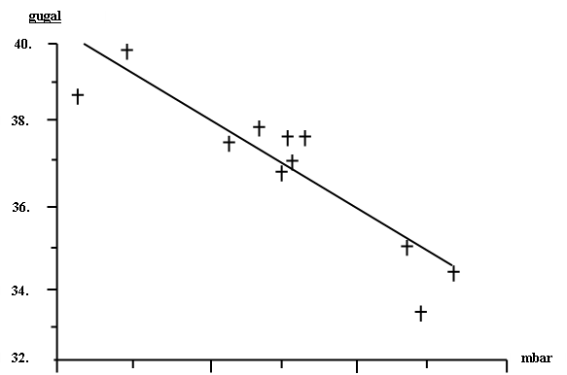

**Figure 1** Regression relationship between atmospheric pressure and gravity observation with FG5/112 absolute gravimeter at Wuhan station

**Table 1.** Comparison of three kinds of ocean loading correction

|  |  |  |
| --- | --- | --- |
| method | Value() | Set std. dev.() |
| 1 | 979350139.1 | 2.14 |
| 2 | 979350140.0 | 1.56 |
| 3 | 979350140.2 | 1.61 |

method 1: without ocean loading correction, method 2: Cartwright-Taylor tidal potential development with 505 waves and observed tidal parameters by SG in Wuhan, method 3: with ocean loading correction given by Hsu and Mao (1984)

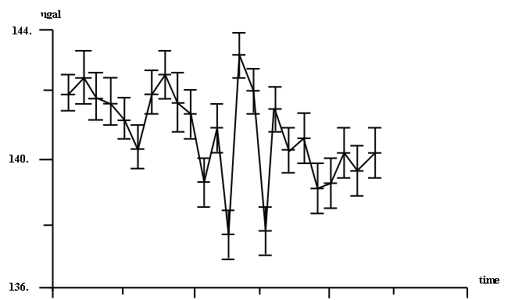

**Figure 2.** The sequences of a typical set of gravity observation



**Figure 3.** The absolute gravity observational results at Wuhan (IGG) station by FG5/112 absolute gravimeter from December 1995 to April 1996.

**Comparison with other results**

We made the repeated measurements at station WTUSM and station IOS for comparison to absolute measurements made by our meter and other ones. The station WTUSM is the station of the Sino-German absolute gravity campaign in China. 1993, and the station IOS is the station of a joint gravity project between the State Seismology Bureau and IfE, University of Hannover. Table 2 and Table 3 give the comparison between results by FG5/112 and those by FG5/10I and JILAO-3 at WTUSM station and IOS station, respectively. The reduction from the effective height to 1000 mm above the station mark was made with the vertical gradients measured by two LaCoste & Romberg (LCR) G-999 and G-1027 relative gravimeters with feedback system. A comparison with results from observations conducted with the F05/101 and JILAO-3 showed a good agreement at two stations. The discrepancies are 3at WTUSM station and 8at IOS station.

**Conclusion**

From the laboratory test conducted with the FG5/112 absolute gravimeter for five months, a precision (standard deviation) of 2is obtained for the mean gravity value under good observational conditions from repeated measurement in the laboratory, a stability of ±2 has been found. Through comparison with the results of other absolute gravimeters, no significant systematic discrepancies have been found, and the those discrepancies are less than 8. A close correlation exists between local atmospheric pressure and gravity observations, the correlation coefficient reaches 0.85, and the value of the barometer admittance factor () is -0.29in the laboratory. Ocean loading tide can cause 1 effect on the mean gravity value, and thus ocean loading correction applied to raw gravity data will improve slightly the accuracy of observations.

**Table 2.** Comparison with J1LAG-3 at Institute of Seismology Station

|  |  |  |  |  |  |  |  |
| --- | --- | --- | --- | --- | --- | --- | --- |
| Meter | Epoch | Result at | mm | Vertical  gradient | Result  at 1000 mm | Drop  std. dev. | Set  std. dev. |
| FG5/112 | 04/96 | 979350585 | 1309 | 316 | 979350684 | 10.95 | 2.3 |
| JILAG-3 | 05/90 | 979350750 | 822 | 324 | 979350692 |  |  |

**Table 3**. Comparison with FG5/101 at WTUSM Station

|  |  |  |  |  |  |  |  |
| --- | --- | --- | --- | --- | --- | --- | --- |
| Meter | Epoch | Result at | mm | Vertical  gradient | Result  at 1000 mm | Drop  std. dev. | Set  std. dev. |
| FG5/112 | 05/96 | 979348426 | 1311 | 332 | 979348531 | 10.95 | 2.3 |
| JILAG-3 | 10/93 | 979348425 | 1310 | 331 | 979348528 | 19.3 | 2.1 |

**Acknowledgments**

The authors are grateful to the China National Natural Science Foundation for providing the grant (No.49574218 and No.49674207). We gratefully acknowledge the friendly support of the Institute of Seismology, SSB and WTUSM during the observation at IOS and WTUSM station. We express our thanks to Mr. D. Liu and H. Li from IOS for gravity gradient measurements.

**References**

Niebauer, T.M., Sasagawa, G.S., Faller, J. E., Hilt, R. and Klopping P., 1995. A new generation of absolute gravimeters, Metrologia, **32**, 159-180.

Hsu, H.T., & Mao, W., 1984, Loading correction of oceanic tides in the mainland of China, Marine Geopyhs. Res., **7**,117-127.

1. 本文发表于《International Association of Geodesy Symposia》，1997年，第117卷，作者为：Houtse HSU，Yong WANG，Weiming ZHANG。