The regional geopotential model in China[1]

Houtse Hsu ----Yang Lu

Institute of Geodesy and Geophysics, Academia Sinica, Wuhan, P.R. of China

Summary.—This paper deals with the approach to calculate the regional high-degree geopotential model in China by use of the regional gravity data. Initial model used here is OSU91A1F given by Rapp, in which a number of systematical corrections neglected in former researches are considered, and the derived formulas have been referred to the ellipsoidal coordinates and ellipsoidal harmonics. Employing the gravity data of 30’ $×$ 30’grids in China and the developed approach, we have obtained a regional geopotential model IGG93C, complete to degree 360. The mean anomalies from the IGG93C model have a RMS discrepancy of $±$ 11.1 mGal with the observed terrestrial anomalies in 30’ $×$ 30’ grids. The new model shows a substantial improvement over the OSU91A1F in the region of China.

Keywords: ellipsoidal harmonics, geopotential model, gravity, IGG93C, OSU91A1F, RMS

Parole chiave: armoniche ellissoidali, e.q.m., gravità, IGG93C, modello geopotenziale, OSU91A1F.

1.—INTRODUCTION

As well known, the accurate geopotential model of the earth may play a very important role in the development of the earth, oceanography and space sciences. Usually the geopotential model can be expressed by the spherical harmonics expansions. The determinations of its global character which represents the longwave length part can be given from satellite solution with enough accuracy, recently the maximum degree has achieved completely to degree 36 for GEM-T2 model and 50 for GEM-T3 model. On the other hand, the defined structures of earth geopotential which reflects the shortwave length character have to be obtained by the terrestrial gravity data.

Along with that the requirement to the high-degree geopotential model is getting higher day by day, in the past several years, a number of advances have taken place in the more accurate high-degree model computation, especially developed in Ohio State University, such as OSU86,OSU89(Rapp and Cruz,1986; Rapp and Pavlis, 1990), and recently OSU91, which complete to degree 360 through the use of 30’ $×$ 30’ mean anomalies combined with the satellites solution GEM-T3, and meets the need of the global use due to its high resolution(Rapp et al., 1991). But, this model has not yet provided sufficient and conclusive results to fully describe the gravity field in China because of the insufficient data used for the model development in this region. According to our comparison, the mean deviation between OUS91F and terrestrial 30’ $×$ 30’ mean values in China can be reach to $±$ 26.3 mGal.

This paper intends to develop a simple approach for the improvement of the high-degree global model with the help of regional gravity data, and set up a new high-degree regional model to be available for the use in China. The principle is quite simple. We choose an initial model and revise it gradually in such a way, that the residual field formed the revised and observed data turns to minimum in whole region. The model obtained in such way is called “fitting model”, and the corresponding approach, <<fitting method>>(Basic,1989).

In the following we deal with the modeling principles based on the ellipsoidal coordinates and ellipsoidal harmonics, and then, derive the fundamental formulas for the computation of regional high-degree geopotential model by means of regional data. Using these derivations and taking OSU91A1F as the initial model, a regional geopotential model IGG93C suitable to the region of China is developed. Finally, some remarks concerning the model accuracy are discussed.

2.—MODELING PRINCIPLE

We start from the fundamental derivation of global model OSU91A1F given by Rapp and Palvis (1991). As well known, the spherical harmonics representation of disturbing geopotential T at a point ($r,θ, λ$) can be defined as:

$T\left(r,θ,λ\right)=\frac{GM}{r}\sum_{n=2}^{∞}{(\frac{a}{r}})^{n}\sum_{m=-n}^{n}{{\overline{C}}_{nm}^{s}}{\overline{Y}}_{nm}(θ,λ)$ (1)

In (1), r is the geocentric distance, $θ$ is the geocentric colatitude, and $λ$ the longitude. GM is the geocentric gravitation constant, while a (the semimajor axis of an adopted mean-Earth ellipsoid) is the scaling factor associated with the fully normalized spherical coefficients, ${\overline{C}}_{nm}^{s}$. In addition,

${\overline{Y}}_{nm}\left(θ,λ\right)={\overline{P}}_{n\left|m\right|}\left(cosθ\right)cos m λ, if m≥0,$

${\overline{Y}}_{nm}\left(θ,λ\right)={\overline{P}}_{n\left|m\right|}\left(cosθ\right)sin m λ, if m<0,$ (2)

Where ${\overline{P}}_{n\left|m\right|}\left(cosθ\right)$ are the fully normalized associated Legendre functions. Let $∆g^{c}$ represent the gravity anomaly after application of all systematic corrections described later on, we have

$∆g^{c} \left(r,θ, λ\right)=$ $\frac{GM}{r^{2}}\sum_{n=2}^{∞}{(n-1)(\frac{a}{r}})^{n}\sum_{m=-n}^{n}{{\overline{C}}_{nm}^{s}}{\overline{Y}}_{nm}(θ,λ)$ (3)

It is nothing just the same as in case of spherical boundary condition. Now the gravity anomalies on earth surface can be calculated from the geopotential coefficients ${\overline{C}}_{nm}^{s}$ by using the expression

$∆g\left(r,θ, λ\right)=∆g^{c} \left(r,θ, λ\right)+\left(ϵ_{h}+ϵ_{r}+ϵ_{p}\right)-δg_{A}-δg_{h^{2}}$ (4)

In (4), ($ϵ_{h}+ϵ_{r}+ϵ_{p}$), $δg_{A}, δg_{h^{2}}$ are the ellipsoid corrections, atmospheric correction and correction due to the neglecting of second-order vertical gradient of the normal gravity respectively, the detail is easily found in paper (Rapp and Palvis, 1990). According to the paper of Rapp and Palvis, if a complete N $×$ 2N set of gravity anomalies $∆{\overline{g}}^{E}$ in terms of discrete area-mean values equiangular blocks on the mean-Earth ellipsoid is given, the fundamental mathematical model to compute the geopotential coefficients ${\overline{C}}_{nm}^{s}$ will be obtained as:

${\overline{C}}_{nm}^{s}=\frac{1}{4πaγ}\sum_{i=0}^{N-1}{r_{i}^{E}\sum_{k=0}^{s^{'}}{\frac{L_{nmk}}{{\overline{S}}_{n-2k,\left|m\right|\left(\frac{b}{E}\right)}}}}\frac{I{\overline{P}}_{n-2k,\left|m\right|}^{i}}{\left(n-2k-1\right)q_{n-2k}^{i}}\sum_{j=0}^{2N-1}{∆{\overline{g}}_{ij}^{E}}IC^{j} if m≥0$

${\overline{C}}_{nm}^{s}=\frac{1}{4πaγ}\sum_{i=0}^{N-1}{r_{i}^{E}\sum_{k=0}^{s^{'}}{\frac{L_{nmk}}{{\overline{S}}_{n-2k,\left|m\right|\left(\frac{b}{E}\right)}}}}\frac{I{\overline{P}}_{n-2k,\left|m\right|}^{i}}{\left(n-2k-1\right)q_{n-2k}^{i}}\sum_{j=0}^{2N-1}{∆{\overline{g}}_{ij}^{E}}IS^{j} if m<0$ (5)

where $γ=\frac{GM}{a^{2}}$

$I{\overline{P}}_{n-2k,\left|m\right|}^{i}=\int_{δ_{i}}^{δ_{j+1}}{{\overline{P}}_{n\left|m\right|}(cosδ)}sin⁡(δ)dδ$ (6)

and I $C^{j}=\int_{λ_{j}}^{λ_{j+1}}{cosλdλ}$

I $S^{j}=\int_{λ_{j}}^{λ_{j+1}}{sinλdλ}$ (7)

In (5), N= $\frac{180}{∆λ}$, $∆λ$ is the longitude (and latitude) extent of the blocks, $δ$ represents the reduced colatitude, b is the semi minor axis of the ellipsoid. The renormalization functions ${\overline{S}}_{nm}$ are related to the associated Legendre functions of the second kind (Gleason, 1986), $s^{'}$ is the greatest integer less than or equal to $\frac{1}{2}$ (n-|m|), is defined by Gleason (1988), $q_{n}$ is the smoothing factors, $r^{E}$ radius of the point on ellipsoid. In addition

$∆{\overline{g}}^{E}=∆\overline{g}+δ{\overline{g}}_{A}+δg_{h^{2}}-\left(IE_{h}+IE_{r}+IE_{p}\right)+{\overline{g}}_{1}$ (8)

Here $g_{1}$ means the correction of analytical downward continuation (Wang, 1988), $∆\overline{g}$ is observed mean gravity anomaly on surface, the others are the mean values in blocks for various corrections. For a certain investigated region, it is easy to obtain the differences between the model values calculated from geopotential coefficients ${\overline{S}}_{nm}$ by (4) and the practical measured gravity anomalies:

$δ∆\overline{g}=∆\overline{g}-\frac{GM}{r^{2}}\sum_{n=2}^{360}{\left(n-1\right)}(\frac{a}{r})^{n}\sum_{m=-n}^{n}{{\overline{C}}_{nm}^{s}}Y_{nρmρ}\left(θ,λ\right)+$

$+δ{\overline{g}}_{A}+δg_{h^{2}}-\left(IE_{h}+IE_{r}+IE_{p}\right)$ (9)

We call regional residual anomalies. The existence of residual field comes mainly from two factors: the initial global model (for example, OSU91A1F in present paper) being a model on the average meaning , and the inaccuracy and incomplete of dataset used for the solution, in particular, lack of terrestrial gravity sources in region of China. Therefore we can use the existing local gravity sources to improve the initial model and meet the need of the application in individual local area.

For this purpose, the whole global is divided into two parts, local part $σ_{1}$ and remainder part $σ_{2}$: only the effect of local part $σ_{1}$ should be taken into account, while the residual field in $σ_{2}$ is assumed to be zero. Applying the observed gravity anomalies in $σ_{1}$ to (5) instead of the original one, the corrections of geopotential coefficients caused by regional residual field may be derived as

$∆{\overline{C}}_{mn}=\frac{1}{4πaγ}\sum_{t=1}^{T}{r_{t}^{E}\sum_{k=0}^{s^{'}}{\frac{L_{nmk}}{{\overline{S}}_{n-2k,\left|m\right|\left(\frac{b}{E}\right)}}}}\frac{{\overline{IP}}_{n-2k,|m|}}{\left(n-2k-1\right)q_{n-2k}^{t}}δ{\overline{g}}_{t}IC_{t} if m≥0$

(10)

$∆{\overline{C}}_{mn}=\frac{1}{4πaγ}\sum_{t=1}^{T}{r_{t}^{E}\sum_{k=0}^{s^{'}}{\frac{L_{nmk}}{{\overline{S}}_{n-2k,\left|m\right|\left(\frac{b}{E}\right)}}}}\frac{{\overline{IP}}_{n-2k,|m|}}{\left(n-2k-1\right)q_{n-2k}^{t}}δ{\overline{g}}_{t}IS_{t} if m<0$

Where T is the total amount of mean residual blocks in local area $σ_{1}$. Thus, the model coefficients of regions gravity field become

${\overline{C}}_{nm}={\overline{C}}_{nm}^{s}+∆{\overline{C}}_{nm}$ (11)

Because the lower-degree set of geopotential coefficients obtained from satellite solutions have enough high accuracy at present, nearly all of the high-degree global model of gravity field taken take advantage of these satellite results to a great extent; for example, in case of OSU91A1F model, solution of GEM-T3 is used. To avoid the distortion of gravity field, we should not change these lower-degree coefficients; one possibility is to introduce the weight functions

${ W}_{n}=\left\{\begin{aligned}0 n<N_{min⁡} \\ \frac{n-N_{min}}{{(N}_{max}-N_{min⁡)}} N_{min⁡}≤n≤N_{max} \\ 1 N_{max}<n \end{aligned}\right.$ (12)

Where $N_{min⁡}$ is the lowest degree that should be kept in original model and $N_{max}$ is the starting degree that should be fully corrected. In this case, formula (11) reduces to

${\overline{C}}_{nm}={\overline{C}}_{nm}^{s}+W_{n}∆{\overline{C}}_{nm}$

It can be seen (12) that the weight functions depend on the parameters $N_{min⁡}$ and $N_{max}$. In general, $N_{min⁡}$ is determined by given global satellites solution and $N_{max}$ is mainly affected by the accuracy of local gravity data; if the dataset has enough accuracy, we can put $N_{max}$ in a little lower, others, in a little higher.

For the practical use a group of computation formulas are listed as follows.

1. Computation of Legendre functions of second kind ${\overline{S}}_{nm}$. It can be done by Gleason’s recursive formula:

${\overline{S}}_{nm}\left(\frac{b}{E}\right)=B_{nm}\sum_{k=0}^{N_{t}}{α_{nmk}}$

$α_{nm,k}=-\frac{\left(n+m+2k-1\right)\left(n+m+2k\right)}{2k\left(2n+22k+1\right)}(\frac{E}{b})^{2}α_{nm,k-1}$ (13)

With

$$α_{nm,0}=1{ B}_{00}=\frac{R}{b}$$

$B_{n,0}=B_{n-1,0}$ $B_{nm}=\sqrt{1+(E/b)^{2}}B_{n,m-1}$ (14)

Where $N_{t}$ is the necessary term to achieve the specifying convergence limitation

1. Computation of Gleason function $L_{nmk}$

$L_{nmk}=(\frac{E}{R})^{2k}\frac{(-1)^{k}\left(n-k\right)!\left(2n-4k+1\right)!}{k!\left(n-2k\right)!\left(2n-2k+1\right)!}\sqrt{\frac{\left(2n-4k+1\right)\left(n-m\right)!\left(n+m\right)!}{\left(2n+1\right)\left(n-2k-m\right)!\left(n-2k+m\right)!}}$ (15)

1. Transformation between reduced and geodetic latitude

$δ=arccos\frac{sinB\sqrt{1-e^{2}}}{(1-e^{2})sin^{2}B}$ (16)

1. Computation of integral formula (6)

Set t= $cosδ$ in (6), we have

$I{\overline{P}}_{nm}(δ)$ = $\int_{t_{s}}^{t_{n}}{{\overline{P}}_{nm}}(t)dt$ (17)

Here $t_{n}$ and $t_{s}$ are corresponding to north and south reduced colatitude of the computed block respectively. The above mentioned integral may ba shoveled by following recursive expressions.

When $n≠m$,

$I{\overline{P}}_{nm}\left(δ\right)=\frac{(n-2)}{(n+1)}\frac{a(n-2)}{a(n-1,m)} I{\overline{P}}_{n-2,m}\left(δ\right)-\frac{a\left(n,m\right)\left(1-t^{2}\right)}{n+1}{\overline{P}}_{n-1,m}\left(t\right)|_{t_{s}}^{t_{n}}$ (18)

When n =m, it includes:

Forward recursive formula (suitable for $δ≤40^{°}$)

$I{\overline{P}}_{nm}\left(δ\right)=\frac{nb(n)(n-1)}{(n+1)} I{\overline{P}}_{n-2,n-2}\left(δ\right)-\frac{t}{n+1}{\overline{P}}_{nn}\left(t\right)|_{t_{s}}^{t_{n}}$

Where

$a\left(n,m\right)=[\frac{\left(2n+1\right)\left(2n-1\right)}{\left(n+m\right)\left(n-m\right)}]^{1/2}$

$b\left(n\right)=[\frac{\left(2n+1\right)}{2n}]^{1/2}$ (19)

$b\left(1\right)=\sqrt{3;}$

the starting values are:

$I{\overline{P}}_{00}\left(δ\right)=t_{n}-t_{s}$

$I{\overline{P}}_{10}\left(δ\right)=\frac{\sqrt{3}}{2}(t_{n}^{2}-{t_{s}}^{2})$

$I{\overline{P}}_{11}\left(δ\right)=\frac{\sqrt{3}}{2}[t(1-t^{2})^{1/2}-arccos⁡(t)]|_{t_{s}}^{t_{n}}$;

Backward recursive formula (suitable for $δ>40^{°}$).

We found that after $δ>40^{°}$ the forward recursive formula given above shows signs of strong unstability, so that it should be replaced instead by backward recursive method.

In this we have

$I{\overline{P}}_{nm}\left(δ\right)=\frac{1}{(n+2)(n+1)b(n+2)}[\left(n+3\right)I{\overline{P}}_{n+2,n+2}\left(δ\right)-t{\overline{P}}_{n+2,n+2}\left(t\right)]|_{t_{s}}^{t_{n}}$;

The starting values $I{\overline{P}}_{max,max}\left(δ\right)$ and $I{\overline{P}}_{max-1,max-1}\left(δ\right)$ can be obtained by Mac Laurin series:

$I{\overline{P}}_{nm}\left(δ\right)=-b(n)b(n-1)⋯b(1)[y^{n+2}(\frac{1}{n+2}+\frac{y^{2}}{2\left(n+4\right)}+\frac{3y^{4}}{8\left(n+6\right)})]|_{y_{s}}^{y_{n}}$.

Here ${y=(1-t}^{2})^{1/2}$, $y_{n}=(1-t_{n}^{2})^{1/2}$, $y_{s}=(1-t_{s}^{2})^{1/2}$,and the necessary term M of summation may be estimated by

M=1+[$M_{0}$]

Where

$M_{0}=\frac{1+ln∈}{lnX}$, $X=sin^{2}\left(\frac{δ_{n}+δ_{s}}{2}\right),$

[*] means making integer, $∈$ is determined according to the accuracy; we use $∈={10}^{-20}$ in this work.

1. Computation of smoothing factors $q_{n}$

Similar to Rapp and Palvis (1990), $q_{n}$ are evaluated based on

$q_{n}^{i}=\left\{\begin{aligned}β_{n}^{i^{2}} if 0≤n≤\frac{N}{3} \\ β_{n}^{i} if \frac{N}{3}<n<N \\ 1 N<n\end{aligned}\right.$

Where N= $\frac{180^{°}}{∆λ}$, and

$β_{n}^{i}=\frac{1}{1-cosψ_{0}^{i}}\frac{1}{2n+1}[P_{n-1}\left(cosψ_{0}^{i}\right)-P_{n+1}\left(cosψ_{0}^{i}\right)]$

Whereψis the semi aperture of a spherical cap having the same area as the equiangular block on the i-th latitude belt. We have

$ψ_{0}^{i}=cos^{-1}[\frac{∆λ}{2π}\left(cosδ_{i+1}-cosδ_{i-1}\right)]$.

It can be proved that if the mean gravity anomalies of the equiangular blocks are independent each other in (5), the difference of internal accuracy between geopotential coefficients of initial model and modifying model will be

$$M_{{\overline{C}}_{nm}^{s}}^{2}-M_{{\overline{C}}_{nm}^{c}}^{2}=\left\{\begin{aligned}0 if N<N_{min} \\ \frac{1}{[4πγ(n-1){\overline{S}}_{n\left|m\right|}\left(\frac{b}{E}\right)]^{2}}\sum_{t=1}^{T}{(\frac{r_{t}^{E}}{a})^{2}(\frac{1}{q_{n}^{t}})^{2}}[I{\overline{P}}_{n\left|m\right|}^{t}]^{2} if N≥N_{min}\end{aligned}\right.$$

(20)

$$[IC^{2} or IS^{2}]^{2}\left[M_{{∆g}_{mt}^{E}}^{2}-M_{∆g_{t}^{E}}^{2}\right](2/{W_{n}}-1)+O(e^{2})$$

Where ${∆g}_{mt}^{E}$ and $∆g_{t}^{E}$ represent modeling and observed anomaly after the correction of downward continuation to ellipsoid. Obviously, $M_{{∆g}_{t}^{E}}^{2}<M_{∆g_{mt}^{E}}^{2}$, so that $M_{{\overline{C}}_{nm}^{c}}^{2}<M_{{\overline{C}}_{nm}^{s}}^{2}$,it means, the accuracy of modifying model is better than the original one due to the supplement of local observation data.

3­.—REGIONAL GEOPOTENTIAL MODEL IGG93C IN CHINA

In this work we update the terrestrial anomaly data in China starting from a $5^{'}×5^{'}$ mean girded file provided by the corresponding Agencies of Surveying and Mapping in China. The total areas is from latitude ${24}^{°}$ N to ${44}^{°}$ N and longitude ${78}^{°}$ E to ${78}^{°}$ E. All of the original data given from this $5^{'}×5^{'}$ girded file have been reduced to IGSN71 system and related to GRS80 system. Then the simple averages are taken to form the mean values of ${30}^{'}×{30}^{'}$ grids. For a small amount of areas devoid of gravity information the anomalies are computed from the OSU91A1F coefficients (complete to degree 360). The resulting file contains totally 3360 ${30}^{'}×{30}^{'}$ data in the area of China.

According to the model calculation, the first step is to compute gravity anomalies in the investigated area by OSU91A1F model, and constitute the residual anomaly field based on (10). Then the corrections of geopotential coefficients result from (11) and (14), in this procedure, we simply put $N_{min}=50$ and $N_{max}=51$, it means that only $M_{n}$ =0 or 1 is used. Finally, a new IGG93C model (complete to degree 360) can be obtained.

We compile a series of software for the model solution. The computation process diagram is show in fig.1, and the main programs and its functions are described as follows.

QGEGRAV.F: to calculated the residual anomalies and relevant statistical results.

RESTK.F: to calculate the corrections of geopotential coefficients based on spherical approximate formulas.

RESTKCH.F: to calculate the corrections of geopotential coefficients based on ellipsoidal expansion, including forward and backward recursive algorithms of the integrals of Legendre functions.

BILDOMDL: to calculate the weight functions and the coefficients of revised model.

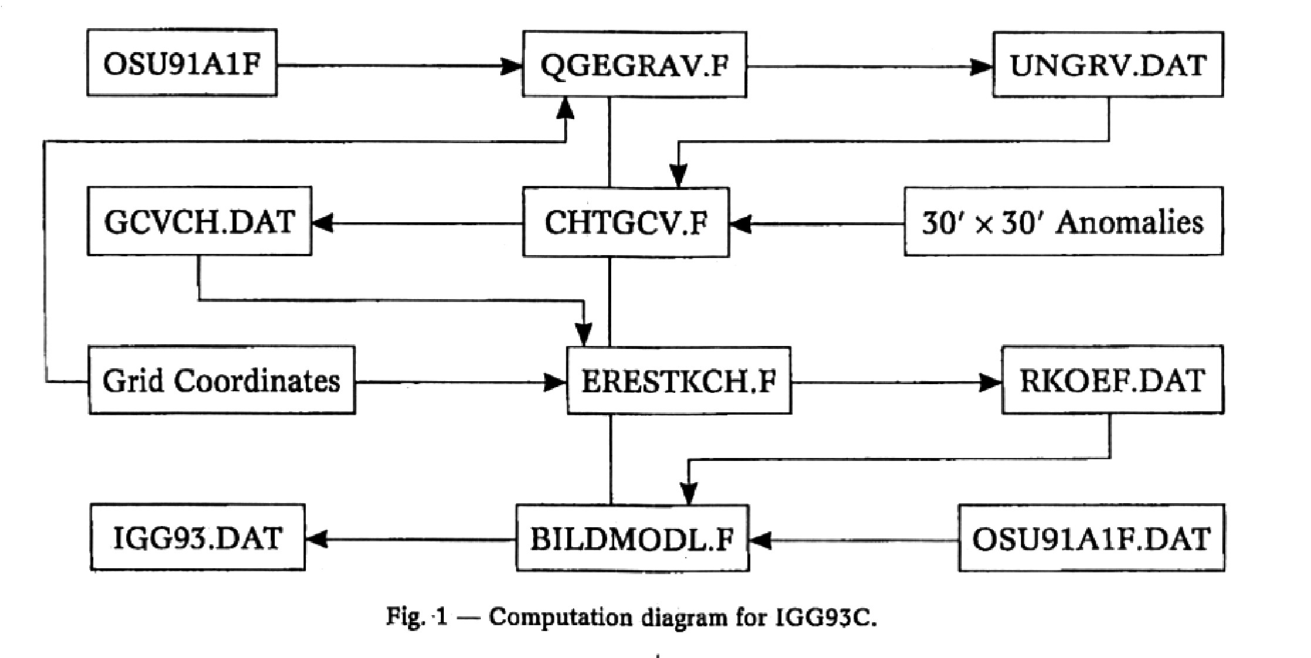

To check the validity of this regional model IGG93C, we compare the degree variances of the geopotential coefficients in modifying and initial models with the degree-variances curve given according to Kaula’s rule. It can be seen in fig.2 that the degree-variance differences between new and initial models are quite small and both of values for new model show up in a little larger than values for initial model in case that the degree is higher than 210, as seen in fig.2. This could be attributed to the enhancement of the information in China.

Comparing the computed anomalies obtained by models OSU91A1F and IGG93C with the observed values in the size of ${30}^{'}×{30}^{'}$ grid, the residuals are shown in fig.4. and fig.3. Obviously, the error in IGG93C is much smaller than in OSU91A1F within the area of China, digital results indicate that the RMS deviation decreases from the original $±$ 26.3 mGal (OSU91A1F model) to $±$ 11.1mGal (IGG93C model), and corresponding magnitude of error undulation decreases from 332.9 mGal to 85.6 mGal, as listed in table 1.

TABLE 1

Accuracy comparison between OSU91A and IGG93C

|  |  |  |
| --- | --- | --- |
| Model | OSU91A1F | IGG93C |
| Mean error  Minimum derivation  Maximum derivation  Range of derivation | $±$ 26.3  -176.4  +156.5  332.9 | $±$ 11.2  -46.7  +38.9  85.6 |

4.—SOME REMARKS

Based on the modeling principle referring to ellipsoidal expansion given by Rapp, it is allowed to obtain a regional high-degree geopotential model by combining the global model with the regional gravity sources. In addition to keep the advantage of origin regional field in more details. In particular, because all of the high-degree models in existence now have not taken into account of the terrestrial gravity data in China, to develop a regional model suitable for China by this method will become of far reaching importance.

The advantages of proposed approach are effective, flexible and simple, it is easily to change the fitting area according to the collected data, to follow the newest model developed in international community, and improve the validity of high-degree model in a particular region. Obviously, the accuracy of the model is directly related to the accuracy of the regional data used, moreover, the determination of weight functions for the corrections of geopotential coefficients are also depending on the accuracy of collected data, and have a direct effect on the spectrum structure of obtained model.

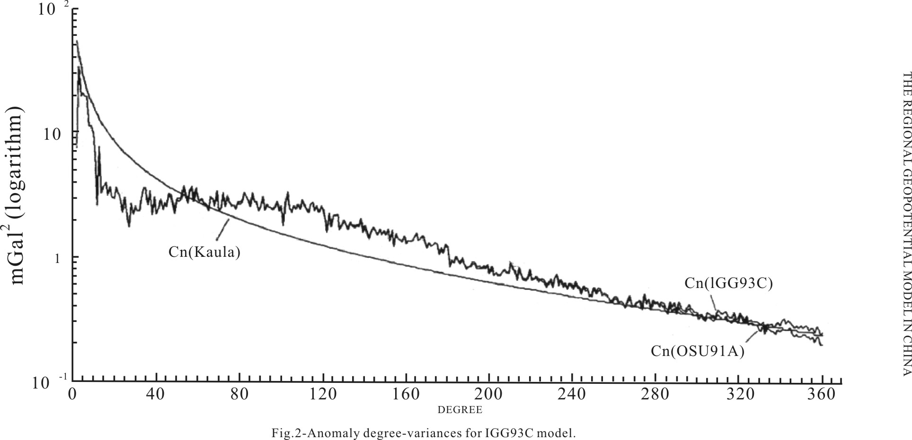

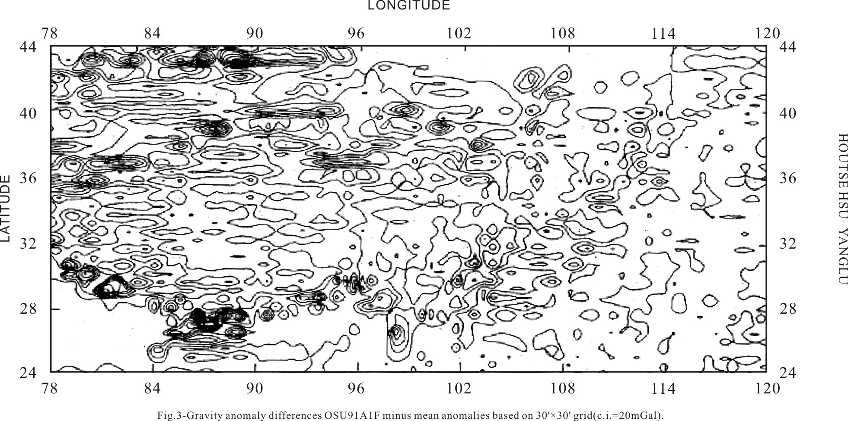

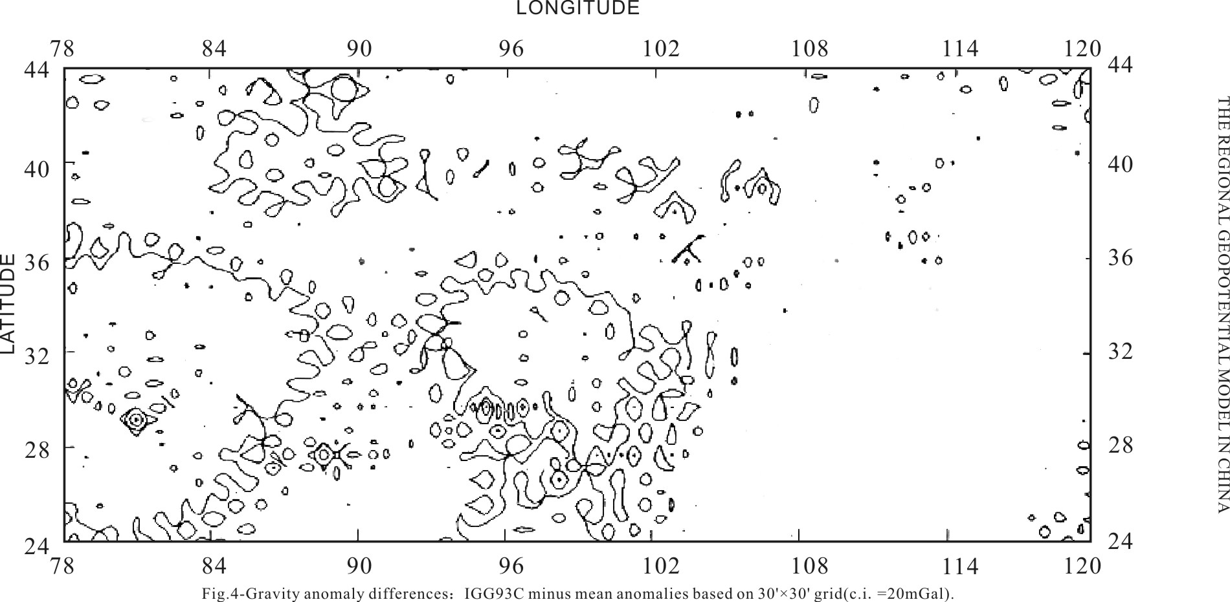

On the basis of the comparison and analysis in Section 3, as the conclusion we may say that the obtained geopotential model IGG93C (complete to degree 360) has good quality in respect of representing the defined structure of gravity field in area of China, its external accuracy is checked to be $±$ 11.1 mGal.

ACKNOWLEDGEMENTS

The research work described in this paper was supported by International Center for Theoretical Physics, Trieste, Italy. Many thanks to prof. Rapp for sending us his earth model OSU91A.fruitful discussion concerning the application of geodetic data to 3-D modeling of lithosphere structure with Prof. Panza and Prof. Schwab are gratefully acknowledged.

REFERENCES

T. Basic (1989) Untersuchungen zur regional Geoidbestimmung mit <dm> Genauigkeit. Wissenschaft Arbeiten der Vermessungswesen der Universitat Hannmver, No.157

D.M. Gleason (1988), Comparing ellipsoidal corrections to the transformation between the geopotential spherical and ellipsoid spectrums. Manusc. Geoid, 13, pp.114-129

W. Heiskanen, H.Moritz (1967), Physical geodesy. W.H. Freeman, New York.

H.T. Hsu (1991), improvement of high-degree gravity field model by using local gravity data. In <<Progress in dynamic geodesy >>

Edited by Zhu, Z.W., pp.28-32,

Seismological Press, Beijing.

C. Jekeli(1988), the exact transformation between ellipsoid and spherical harmonic expansions.Manusc.Geod.,13,pp.106-113.

N.K.Palvis (1988), modeling and estimation of a low degree geopotential model from terrestrial gravity data. Rep. 386, Dept. of Geod. Sci. and Surv., Ohio State Univ., Columbus.

R.H. Rapp. J.Y. Cruz(1986),Spherical harmonics expansions of the Earth’s gravitational potential to degree 360 using ${30}^{'}$ mean anomalies. Rep.376, Dept. of Geod. Sci. and Surv., Ohio State Univ. Columbus.

R.H. Rapp, N.K. Palvis(1990), the development and analysis of geopotential coefficient model to spherical harmonic degree 360.J.Geophys.Res., 95,No.B13,pp.21885-21911.

R.H. Rapp. Y. M. Wang. N.K. Palvis (1991), the Ohio state 1991 geopotential and sea surface topography harmonic coefficient models.Rep.401, Dept. of Geod. Sci. and Surv, Ohio State Univ., Columbus

Y.M. Wang (1988), down continuation of the free air gravity anomalies to the ellipsoid using the gradient solution. Poisson’s integral and terrain correction: Numerical comparison and the computations. Rep.393, Deod.Sci. and Surv., Ohio State Univ., Columbus.

1. 本文发表于《BOLLETINO DI GEODESIA E SCIENZE AFFINI –N.2》,1995年，作者为：Houtse Hsu ，Yang Lu。